Graphic Designer
404.580.5432
leonfite04@gmail.com panickingartist.wixsite.com/leon-fite
in/leon-fite


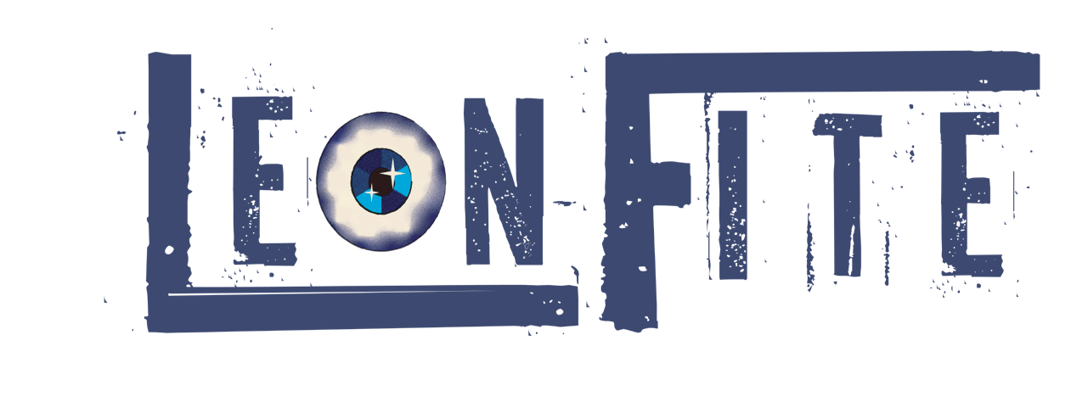
Design Experience
Kelly Kouture Branding,
Savannah, GA, 2026 - Present
ø Collaborated with a client to create a cohesive and compelling brand identity
ø Utilized and collected research to formulate a design
strategy supported by previous industry successes
ø Coordinated with client to foster
clear communication and guidelines
ø Created a reusable and understandable branding guideline
Brand Identity Design for Local Business Weatherford, TX, 2019
ø Developed a complete brand identity including
logo, colors, and typography, for a local startup
ø Conducted market research to ensure the design aligned with target audience and business goals
ø Designed a series of social media promotions
for a fund raising campaign
ø Collaborated with the marketing team to ensure cohesive visual messaging across all platforms

Additional Experience
Lizzy’s Burger Bar and Grill, Savannah, GA Server, 2024-2026
ø Enhanced customer satisfaction through
attentive service and expert up-selling.
ø Demonstrated strong multitasking skills by managing multiple tables simultaneously.
ø Collaborated with team members to ensure eficient
workflow and excellent guest experiences.
Churhills, Savannah, GA Server, 2026 - Present
ø Delivered attentive, high-volume service
by managing multiple tables
ø Eficiently while maintaining accuracy and a positive guest experience.
ø Collaborated with kitchen and bar staff to
ensure timely order execution, resolve issues quickly, and maintain smooth service flow.

Education
B.F.A. in Graphic Design Savannah College of Art and Design (SCAD)
Savannah, GA Expected Graduation May 2026 Dean’s List 2023, 2024

Skills
Technical Layout Design Typography
Illustration Branding and
Identity Color Theory Logo Creation
Software Adobe Photoshop Adobe Illustrator Adobe InDesign
Figma Procreate
Canva AutoCAD
MAYA
Clipstudio Paint

Awards
SCAD
Academic Achievement Scholarship Academic Honors Scholarship
Certifications Adobe Illustrator Adobe Photoshop
Adobe Visual Design

